ONTARIO CATHOLIC SCHOOL BOARD BUSINESS OFFICIALS’ ASSOCIATION
Association des administrateurs et des administratrices d’affaires des écoles catholiques de l’Ontario

M I N U T E S

2016 ANNUAL GENERAL MEETING
Thursday September 29, 2016
Nottawasaga Resort

President Angelo Romano opened the 62^{h} Annual General Meeting of the Association. Board of Directors were present as follows:

Present:

Angelo Romano, President
Paul DeCock Vice President
Martin Farrell
Theresa Davis
Michelle Lamarche
Betty Stavropoulos
Kevin Sun

Peter Marchini, Executive Director

- Call To Order

President Angelo Romano called the meeting to order at 10:50AM.

2. Opening Prayer

“Prayer for a Meeting” – prayed by all present.

3. Approval of Agenda

Motion: That the agenda for the OCSBOA 2016 Annual General Meeting be approved.
Moved by: Derek Schmidt Seconded by: Suzanne White

Carried

4. Approval of 2014 AGM held on October 2, 2014

Motion: That the Minutes of the OCSBOA Annual General Meeting held on October 2, 2014 be approved as presented.

Moved by: Joe O’Hara Seconded by: Laura Frees

Carried

5. President’s Report
President Angelo Romano reviewed his report with the membership. Angelo thanked the Directors who have served on the association. He indicated that the Board will need to continue to improve on ways to attract members and delegates to our conference. He thanked the Corporate Sponsors, guest speakers and Directors of Education that permit us to attend. He congratulated our award recipients Joe O’Hara and Wally Easton. He also expressed the importance of OCSBOA to Catholic Education.

Motion: That the President’s Report be received.
Moved by: Ann Marie Nicholson Seconded by: Laura Frees

Carried

6. Executive Director’s Report

Executive Director Peter Marchini presented his report to the membership. Peter expanded upon the 2015-16 Financial Audit in particular the deficit that was incurred as a result of the need to cancel the 2015 Conference. The ED report is attached.

Motion: That the Executive Director’s Report be received.
Moved by: Donna Lee Reid Seconded by: AM Nicholson
Carried

Audited Statements

7.1 2015-16 and 2014-15 Financial Statement and Auditor’s Review

The Financial Statement and Financial Statement Reviewer’s Report for the fiscal year September 1, 2014 to August 31, 2015 and the fiscal year September 1, 2015 to August 31, 2016 were published in the 2016 Conference Reports Package and circulated to the membership. The financial statements were prepared by Peter Marchini and reviewed by Roma and Associates a Chartered Accounting firm located in Windsor Ontario. For the fiscal period 2015-16 the Association incurred a deficit of $21,791 due to the cancellation of the 2015 Conference.

Motion: That the Financial Statement and the Financial Statement Reviewer’s Report for the fiscal years September 1, 2014 to August 31, 2015 and September 1, 2015 to August 31, 2016 be approved as presented.

Moved by: Dave Bilenduke Seconded by: Paul DeCock

Carried

- Committee Reports

Each of the Directors presented their committee report.

8.1 Human Resources- Angelo reported on the activities of the HR Committee which meets 5 or 6 times per year. He reviewed the many issues that School Boards have had to deal with over the past year.

8.2 Conference- Angelo Romano reviewed the Conference Planning report and provided explanation as to the cancellation of the 2015 Conference. He indicated that the 2017 Conference will be held at the Niagara Falls Hilton.

8.3 Membership Services-Peter reviewed the Membership Services report and spoke to the drop in membership and how it has affected the associations revenue position. He indicated more effort will be made in the coming year to attract new members.

8.4 Ministry Liaison- Paul DeCock reviewed the report with the membership.

8.5 OCSTA Liaison- Martin Farrell reviewed the report for the membership.

Motion: that the reports be accepted as presented.

Moved by: Paula Dunn Seconded by: Dave Bilenduke

Carried

- Honorary Membership Election

Angelo Romano provided Wally Easton’s name for Honorary Membership.

Motion: that Wally Easton be awarded an Honorary Membership.

Moved by: Paula Dunn Seconded by: Joe O’Hara

Carried

- Election to Board of Directors

Angelo Romano reviewed the Election of Board Members report. He indicated that he would now be the Past President and Paul DeCock would become President. As well three Directors Michelle Lamarche, and Martin Farrell, and Betty Stavropoulos whose terms have expired would be leaving there is a need to elect three new Directors. He asked the membership for any nominations.

Theresa Davis nominated Joe O’Hara who indicated he was willing to stand.

Frank Ferrante nominated Maia Puccetti who indicated she was willing to stand.

Dave Bilenduke seconded the nominations.

- 2015 Conference Dates and Location

President Angleo Romano reported that the 63rd Annual conference will be held at the Fallsview Hilton in Niagara Falls from September 27-29 2017.

- Other Business

Angelo Romano reported on the new board will be looking at Future Directives and Initiatives. He also indicated that the Association has a great deal of work to do in the new year with an emphasis on membership and membership services. One delegate asked about social activities for the Wednesday afternoon. Angleo indicated that a few years back the Ministry of Education had made issue over the fact that School Board funds were being spent on social activities. This item will be looked again for the 2017 Conference.

- Final Remarks
Christine Cutterbuck from iSYS asked if OCSBOA would consider allowing corporations to join as associate members.

14. Adjourment Time 11:30AM

To be approved by the Membership at the AGM held on September 28, 2017

Peter Marchini
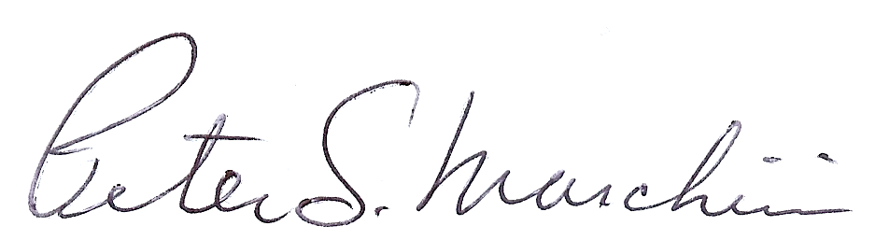

Peter Marchini, Executive Director

